What Is Economics, and Why Is It Important?
- Meaning and Origin:
  - Economics is one of the most exciting disciplines in the social sciences.
  - The word economy comes from the Greek phrase meaning “one who manages a household.”
  - The science of economics in its current form is about two hundred years old.
- Definition of Economics:
  - Economics is the study of how humans make decisions in the face of scarcity.
  - These decisions can be:
    - Individual decisions
    - Family decisions
    - Business decisions
    - Societal decisions
- Concept of Scarcity:
  - Scarcity is a fact of life—human wants for goods, services, and resources exceed what is available.
  - Resources such as labor, tools, land, and raw materials are necessary to produce goods and services but exist in limited supply.
  - The ultimate scarce resource is time—everyone, rich or poor, has only 24 hours a day to:
    - Earn income
    - Acquire goods and services
    - Enjoy leisure time
    - Sleep
- Limited Nature of Resources:
  - At any point in time, only a finite amount of resources is available.
  - Example (U.S., 2015):
    - Labor force: over 158 million workers
    - Total land area: 3,794,101 square miles
  - Though large, these numbers are not infinite.
  - Because resources are limited, so are the goods and services that can be produced.
  - Since human wants are virtually infinite, scarcity becomes a fundamental problem.
- Controversy in Definition:
  - There is no universally accepted definition of economics.
  - Different economists defined it from different perspectives:
a. Wealth definition
b. Welfare definition
c. Scarcity definition
d. Growth definition
  - Hence, its definition varies as the nature and scope of the subject evolve over time.
- Formal and Commonly Accepted Definition:
  - Economics is a social science that studies the efficient allocation of scarce resources to attain the maximum fulfillment of unlimited human needs.
  - As a science of choice, economics studies how people choose to use scarce or limited productive resources (land, labor, equipment, technical knowledge, etc.) to produce various commodities.
- Statements Derived from the Definition:
  - Economics studies scarce resources.
  - It studies the allocation of resources.
  - Allocation should be efficient.
  - Human needs are unlimited.
  - The objective of economics is to study how to satisfy unlimited human needs to the maximum possible degree by allocating resources efficiently.
The rationales of economics
There are two fundamental facts that provide the foundation for the field of economics.
1) Human(society‗s)material wants are unlimited.
2) Economic resources are limited (scarce).
The basic economic problem is about scarcity and choice since there are only limited amount
of resources available to produce the unlimited amount of goods and services we desire. Thus,
economics is the study of how human beings make choices to use scarce resources as they seek
to satisfy their unlimited wants. Therefore, choice is at the heart of all decision-making. As an
individual, family, and nation, we confront difficult choices about how to use limited resources
to meet our needs and wants. Economists study how these choices are made in various settings;
evaluate the outcomes in terms of criteria such as efficiency, equity, and stability; and search
for alternative forms of economic organization that might produce higher living standards or a
more desirable distribution of material well-being.

Scope and method of analysis in economics
Scope of economics
The field and scope of economics is expanding rapidly and has come to include a vast range of
topics and issues. In the recent past, many new branches of the subject have developed,
including development economics, industrial economics, transport economics, welfare
economics, environmental economics, and soon. However, the core of modern economics is
formed by its two major branches: microeconomics and macroeconomics. That means
economics can be analyzed at micro and macro level.
A. Microeconomics is concerned with the economic behavior of individual decision making
units such as households, firms, markets and industries. In other words, it deals with how
households and firms make decisions and how they interact in specific markets.
B. Macroeconomics is a branch of economics that deals with the effects and consequences of
the aggregate behaviour of all decision making units in a certain economy. In other words,
it is an aggregative economics that examines the interrelations among various aggregates,
their determination and the causes of fluctuations in them. It looks at the economy as a
whole and discusses about the economy-wide phenomena.

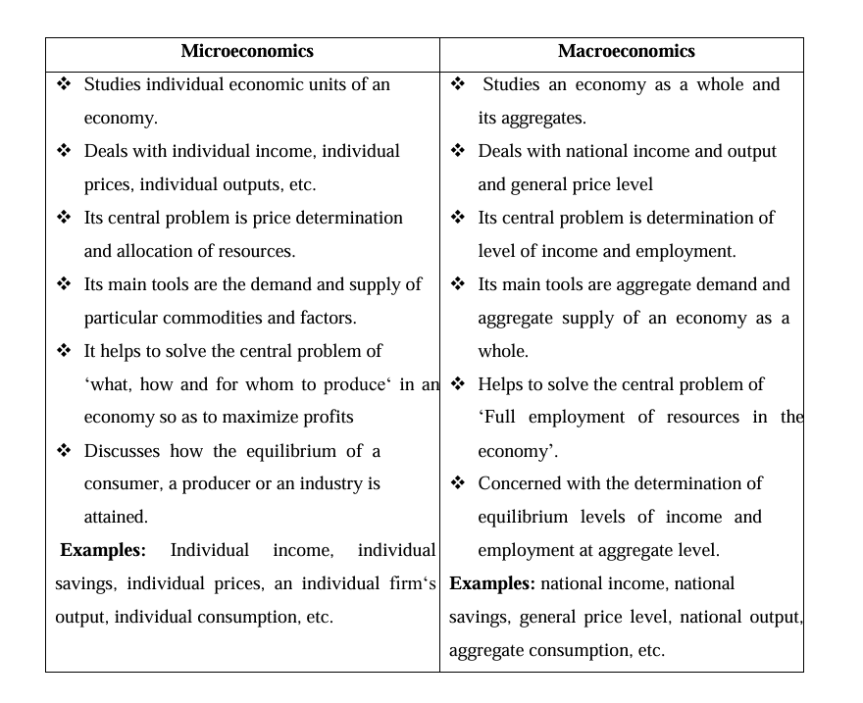
Positive and Normative Analysis
- Two Perspectives of Economic Analysis:
  - Economics can be analyzed from two perspectives:
a. Positive Economics
b. Normative Economics

1. Positive Economics
- Meaning:
  - Positive economics is concerned with the analysis of facts and attempts to describe the world as it is.
  - It answers questions such as:
    - What was?
    - What is?
    - What will be?
- Nature:
  - It does not judge whether a system is good or bad, better or worse.
  - It focuses only on objective facts and real situations.
- Examples of Positive Statements:
  - The current inflation rate in Ethiopia is 12 percent.
  - Poverty and unemployment are the biggest problems in Ethiopia.
  - The life expectancy at birth in Ethiopia is rising.
- Verification:
  - All the above statements are positive statements because they are concerned with real facts and information.
  - Any disagreement on positive statements can be checked and verified by referring to facts and data.

2. Normative Economics
- Meaning:
  - Normative economics deals with questions such as:
    - What ought to be?
    - What should the economy be?
  - It evaluates the desirability of alternative outcomes based on one’s value judgments about what is good or bad.
- Nature:
  - Normative economics is value-laden and subjective in nature.
  - Since it involves judgments, what is considered good by one person may not be the same for another.
  - Normative analysis is therefore a matter of opinion and cannot be proved or rejected using factual evidence.
- Examples of Normative Statements:
  - The poor should pay no taxes.
  - There is a need for government intervention in the economy.
  - Females ought to be given job opportunities.
- Resolution of Disagreement:
  - Any disagreement on a normative statement cannot be verified by facts.
  - Such disagreements are usually resolved by voting or through public opinion.

Inductive and Deductive Reasoning in Economics
- Objective of Economics as a Science:
  - The fundamental objective of economics, like any other science, is the establishment of valid generalizations about certain aspects of human behaviour.
  - These generalizations are known as theories.
  - A theory is a simplified picture of reality.
  - Economic theory provides the basis for economic analysis, which uses logical reasoning.
- Types of Logical Reasoning in Economics:
  - There are two methods of logical reasoning used in economics:
a. Inductive reasoning
b. Deductive reasoning

a) Inductive Reasoning
- Meaning:
  - Inductive reasoning is a logical method of arriving at a correct general statement or theory based on several independent and specific correct statements.
  - In short, it is the process of deriving a principle or theory by moving from facts to theories and from particular to general in economic analysis.
- Steps Involved in the Inductive Method:
  - Selecting a problem for analysis
  - Collection, classification, and analysis of data
  - Establishing cause-and-effect relationships between economic phenomena

b) Deductive Reasoning
- Meaning:
  - Deductive reasoning is a logical way of arriving at a particular or specific correct statement starting from a correct general statement.
  - In short, it deals with drawing conclusions about economic phenomena from certain fundamental assumptions, truths, or axioms through a process of logical arguments.
- Nature of Deductive Reasoning:
  - The theory derived through this method may agree or disagree with the real world.
  - Therefore, the validity of the theory must be checked against real-world facts.
  - The process involves moving from general to particular conclusions.
- Major Steps in the Deductive Approach:
  - Problem identification
  - Specification of the assumptions
  - Formulating hypotheses
  - Testing the validity of the hypotheses

Scarcity, Choice, Opportunity Cost, and Production Possibilities Frontier

Introduction
- The central purpose of economic activity is the production of goods and services to satisfy consumers’ needs and wants.
- This is done to meet:
  - Basic needs for survival, and
  - Ever-growing demands for an improved lifestyle or standard of living.

1. Scarcity
- The fundamental economic problem faced by any human society is the problem of scarcity.
- Scarcity refers to the fact that all economic resources that a society needs to produce goods and services are finite or limited in supply.
- However, their limitation must be understood in relation to human wants.
- Thus, scarcity reflects an imbalance between our wants and the means to satisfy them.

Examples of Scarce Resources
- All types of human resources – manual, intellectual, skilled, and specialized labor.
- Most natural resources – land (especially fertile land), minerals, clean water, forests, and wild animals.
- All types of capital resources – machines, intermediate goods, infrastructure, etc.
- All types of entrepreneurial resources.

Classification of Economic Resources
- Labour:
  - Refers to the physical and mental efforts of human beings in the production and distribution of goods and services.
  - Reward: Wage.
- Land:
  - Refers to natural resources or all the free gifts of nature usable in production.
  - Reward: Rent.
- Capital:
  - Refers to all manufactured inputs used to produce other goods and services.
  - Examples: equipment, machinery, transport, and communication facilities.
  - Reward: Interest.
- Entrepreneurship:
  - Refers to a special type of human talent that helps organize and manage other factors of production to produce goods and services, and bears the risk of losses.
  - Reward: Profit.

Types of Resources
- Free Resources:
  - A resource is said to be free if the amount available to a society is greater than the amount people desire at zero price.
  - Example: sunshine.
- Scarce (Economic) Resources:
  - A resource is scarce if the amount available to a society is less than what people want to have at zero price.

Entrepreneurs Are Individuals Who:
- Organize factors of production to produce goods and services.
- Make basic business policy decisions.
- Introduce new inventions and technologies into business practice.
- Look for new business opportunities.
- Take risks of making losses.

Note: Scarcity vs. Shortage
- Scarcity does not mean shortage.
- A good is scarce if the amount available is less than what people wish to have at zero price.
- Shortage occurs when people are unable to get the amount they want at the prevailing (market) price.
- Difference:
  - Shortage is specific and short-term, while
  - Scarcity is universal and everlasting.

2. Choice
- If resources are scarce, then output will be limited.
- If output is limited, we cannot satisfy all our wants.
- Therefore, choices must be made regarding what to produce and what not to produce.
- Because of scarcity, individuals, firms, and governments are forced to make choices on:
  - What output to produce,
  - In what quantity, and
  - What output not to produce.
- Hence, scarcity implies choice, and choice implies cost.
- Whenever a choice is made, an alternative opportunity is sacrificed, and this cost is called opportunity cost.

3. Opportunity Cost
- In a world of scarcity, having more of one thing means having less of another.
- The value of the next best alternative that must be sacrificed is the opportunity cost of the decision.
Definition:
- Opportunity cost is the amount or value of the next best alternative that must be sacrificed (forgone) in order to obtain one more unit of a product.

Example:
- Suppose a country can use its limited resources to produce either cloth or computers.
- If the given resources can produce one meter of cloth or 20 units of computers,
- Then the opportunity cost of one meter of cloth is the 20 units of computers that must be sacrificed.

Key Points About Opportunity Cost:
- It is measured in goods and services, not in money terms.
- It should be in line with the principle of substitution – when the opportunity cost of an activity increases, people substitute other activities in its place.

Conclusion:
- Scarcity forces societies to make choices.
- Every choice involves opportunity cost—the sacrifice of the next best alternative.
- Understanding scarcity, choice, and opportunity cost helps economists and policymakers make efficient decisions about the allocation of limited resources.

Microeconomics and Macroeconomics

1. Scope of Economics
- Economics acknowledges that production of useful goods and services can also create problems like environmental pollution.
- It explores how investing in education helps to develop workers’ skills.
- It examines when big businesses or labor unions operate in a way that benefits society as a whole and when they act only for their own benefit at the expense of others.
- It studies how government spending, taxes, and regulations affect decisions related to production and consumption.
- Economics, therefore, covers a wide range of topics and issues related to individual and national economic behavior.

2. Division of Economics
- Economics is divided into two main branches:
  - Microeconomics
  - Macroeconomics
- Microeconomics focuses on the actions of individual agents within the economy, such as households, workers, and businesses.
- Macroeconomics looks at the economy as a whole and focuses on broad issues like:
  - Growth of production
  - Unemployment levels
  - Inflationary rise in prices
  - Government deficits
  - Levels of exports and imports
- Microeconomics and macroeconomics are not separate subjects but are complementary perspectives on the overall economy.

3. Analogy: The Lake Ecosystem
- To understand why both perspectives are useful, economics can be compared to studying a biological ecosystem (like a lake):
  - One person might focus on specific elements such as algae, plants, fish, or snails — this represents microeconomics.
  - Another might look at the entire ecosystem — what eats what, how balance is maintained, and what factors disturb it — this represents macroeconomics.
- Both approaches are useful and study the same system (lake/economy) but from different viewpoints.

4. Relationship Between Micro and Macro
- Micro and macro insights complement each other, just like in the study of a lake:
  - Micro insights (individual plants/animals) help in understanding the overall ecosystem.
  - Macro insights (overall ecosystem balance) help explain the environment in which individual species live.
- Similarly, in economics:
  - Micro decisions (by businesses and households) are influenced by the macroeconomic condition.
  - For example, firms are more likely to hire workers when the overall economy is growing.
- The performance of the macroeconomy ultimately depends on the microeconomic decisions made by individual households and firms.

Microeconomics
- Microeconomics deals with the behavior of individual economic units such as households, workers, and firms.
- It answers questions like:
  - What determines how households and individuals spend their budgets?
  - What combination of goods and services best fits their needs and wants, given their budget constraints?
  - How do people decide whether to work, and if so, full-time or part-time?
  - How do people decide how much to save for the future or whether to borrow to spend beyond their current means?
- For firms, microeconomics addresses questions such as:
  - What determines the products a firm produces and how many of each?
  - What determines the prices a firm charges?
  - How does a firm decide how to produce its products?
  - What determines how many workers it will hire?
  - How will a firm finance its business operations?
  - When will a firm expand, downsize, or close?
- In microeconomics, we study: CFLF
  - Theory of consumer behavior
  - Theory of the firm
  - Markets for labor and other resources
  - Market failures and why markets sometimes fail to operate efficiently.

Macroeconomics
- Macroeconomics deals with the economy as a whole and examines aggregate outcomes.
- It answers key questions such as:
  - What determines the level of economic activity in a society?
  - What determines how many goods and services a nation produces?
  - What determines how many jobs are available in the economy?
  - What determines a nation’s standard of living?
  - What causes the economy to speed up or slow down?
  - What causes firms to hire more workers or lay them off?
  - What causes the economy to grow over the long term?

Goals of Macroeconomic Analysis
- The macroeconomic health of an economy is determined by several key goals:
  - Growth in the standard of living SUI
  - Low unemployment
  - Low inflation
- To achieve these goals, governments use macroeconomic policies, which include:

A. Monetary Policy
- Monetary policy involves managing bank lending, interest rates, and financial capital markets.
- It is conducted by a nation’s central bank.
- In the United States, the central bank is the Federal Reserve.

B. Fiscal Policy
- Fiscal policy involves government spending and taxation.
- It is determined by a nation’s legislative body.
- In the United States, fiscal policy is managed by:
  - Congress, and
  - The executive branch, which originates the federal budget.
- These (monetary and fiscal policy) are the main tools of the government for managing the economy.

Expectations and Realities
- Many people believe that government can fix any economic problem through these policies.
- However, it is important to question how realistic that expectation truly is.

How Economists Use Theories and Models to Understand Economic Issues
- John Maynard Keynes’ View:
  - Keynes (1883–1946), one of the greatest economists of the 20th century, emphasized that economics is not just a subject but a way of thinking.
  - He wrote that “[Economics] is a method rather than a doctrine, an apparatus of the mind, a technique of thinking, which helps its possessor to draw correct conclusions.”
  - Meaning: Economics teaches you how to think, not what to think.
- Economists’ Perspective:
  - Economists view the world differently from other disciplines like anthropology, biology, or psychology.
  - They use economic theories based on specific assumptions about human behavior.
  - These assumptions may differ from those used in other social sciences.
- Purpose of Theories:
  - A theory is a simplified representation showing how two or more variables interact.
  - It helps simplify complex real-world issues into essential elements.
  - A good theory is simple enough to understand yet complex enough to capture key features of reality.
- Difference Between Theory and Model:
  - A theory is a more abstract representation.
  - A model is a more applied or empirical representation.
  - Models are used to test theories, though both terms are often used interchangeably in economics.
- Analogy with Architecture and Product Design:
  - Just as an architect builds a model of a building or a company builds a prototype of a new product, economists use models to represent how economic systems function.
  - These models are simplified, but they help demonstrate how things work in the real world.
- Circular Flow Diagram (Basic Economic Model):
  - A key model in economics that shows how the economy operates between households and firms.
  - These groups interact in two markets:
    - Goods and services market – Firms sell and households buy.
    - Labor market – Households sell labor and firms buy.
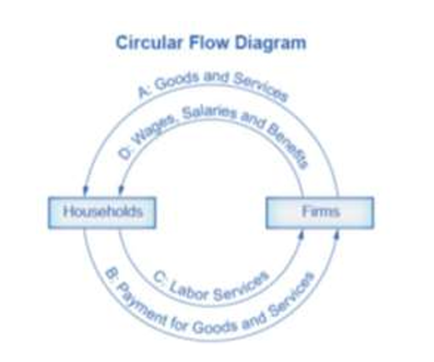
- Explanation of Circular Flow Diagram:
  - Arrow A: Firms produce and sell goods/services to households.
  - Arrow B: Households pay firms for these goods/services (firms earn revenue).
  - Arrows A and B represent the product (goods & services) market.
  - Arrow C: Households provide labor and other resources (land, capital, raw materials) to firms.
  - Arrow D: Firms pay households for these inputs (wages, rent, profits, etc.).
  - Arrows C and D represent the factor (input) market.
- Inner and Outer Circles of the Model:
  - Outer Circle: Represents the product market (households demand, firms supply).
  - Inner Circle: Represents the labor market (households supply labor, firms demand labor).
- Simplification in the Model:
  - The circular flow model simplifies reality to make understanding easier.
  - It focuses on the essential interactions between households and firms.
  - Real-world additions could include:
    - Financial markets
    - Government sectors
    - Foreign trade (imports and exports)
- Purpose of the Model:
  - It provides a clear picture of how goods, services, and money circulate in the economy.
  - Demonstrates how the product and labor markets function.
- Economists’ Use of Theories:
  - Economists use theories like a toolkit — selecting the most appropriate one for a given issue or problem.
  - Theories help derive insights and understand relationships between economic variables.
- Representation of Theories:
  - Theories can be represented using:
    - Diagrams
    - Graphs
    - Mathematical equations
  - In introductory economics, graphs are the most common form.
- Role of Graphs in Economic Thinking:
  - Economists use graphs not just to illustrate answers but to derive them.
  - At advanced levels, solving economic problems often requires model-based graph analysis.
- Application in Micro and Macroeconomics:
  - Both microeconomics and macroeconomics rely on theories and models for explanation and analysis.
  - The supply and demand model is among the most well-known examples.

Economic Systems
An economic system is a set of organizational and institutional arrangements used by a society to answer basic economic questions — what, how, and for whom to produce.
Main types: Capitalism, Command (Socialist), and Mixed Economy.

1️⃣ Capitalist Economy (Free Market / Laissez-Faire System)
Definition:
All means of production are privately owned; production is for profit; minimal government interference.
Features: PCPCP LSI
- Private property: Ownership of productive assets by individuals.
- Consumer sovereignty: Freedom of consumers to choose goods/services.
- Profit motive: Entrepreneurs aim for maximum profit.
- Competition: Exists among buyers, sellers, and workers.
- Price mechanism: Determines production & distribution.
- Limited government role: Only in defense & law enforcement.
- Self-interest: Guides all economic activities.
- Income inequality and negative externalities (e.g., pollution).
Advantages: HIDE GF H
- Flexibility & adaptability.
- Decentralized decision-making.
- Higher per-capita income & living standards.
- Innovation and new consumer goods.
- Growth of entrepreneurship.
- Efficient use of resources.
- High capital formation.
Disadvantages:
- Income inequality & social imbalance.
- Unbalanced regional development.
- Exploitation of labor.
- Negative externalities (pollution, etc.).

2️⃣ Command Economy (Socialist Economy)
Definition:
All production and distribution means are owned and controlled by the state.
Features: CC SFE
- Collective ownership: No private property.
- Central planning: Resource allocation by government.
- Strong government control.
- Focus on social welfare.
- Equality of income: No wealth accumulation.
Advantages:
- No wasteful competition.
- Balanced regional and sectoral growth.
- Elimination of private monopolies and inequalities.
Disadvantages:
- No automatic price mechanism.
- Lack of incentive for hard work or efficiency.
- Absence of economic freedom.
- Bureaucratic delays and red-tapism.

3️⃣ Mixed Economy
Definition:
Combination of capitalism and socialism — coexistence of public and private sectors.
Features: PEE PE
- Public + private sector coexistence: Defined roles.
- Economic welfare: Priority through government policies.
- Economic planning: Coordinated growth via planning.
- Price mechanism: Operates in private sector; regulated in public.
- Economic equality: Achieved via taxation, subsidies, limits on property.
Advantages:
- Combines benefits of capitalism (profit motive, efficiency) & socialism (welfare, equality).
- Adequate economic freedom.
- Planned and rapid economic development.
- Promotes social welfare and reduces inequalities.
Disadvantages:
- Possible inefficiency in both sectors.
- Economic instability if not properly regulated.
- Corruption and black markets due to poor policy implementation.

✅ Summary Table:
Type | Ownership | Decision-Making | Role of Govt | Main Motive | Key Issues
Capitalist | Private | Market (price mechanism) | Minimal | Profit | Inequality, exploitation
Command | State | Central planning | Full control | Social welfare | Inefficiency, lack of freedom
Mixed | Both | Market + Planning | Moderate | Profit + Welfare | Corruption, inefficiency

